

**COMSATS University Islamabad,**

**Sahiwal Campus.**

**Dental Disease Detection**

**A Project Presented To**

**COMSATS University Islamabad,**

**Sahiwal Campus**

**In partial fulfillment**

**of the requirement for the degree of**

***Bachelor of Science in Software Engineering (2020-2024)***

***By***

**Umair Ali CIIT/FA20-BCS-123/SWL**

**Aamna Zahid CIIT/FA20-BCS-151/SWL**

**Abdullah Shafiq CIIT/FA20-BCS-153/SWL**



**COMSATS University Islamabad,**

**Sahiwal Campus**

**Report Document**

of

**Dental Disease Detection**

*By*

|  |  |
| --- | --- |
| **Aamna Zahid** | **CIIT/FA20-BCS-151/SWL** |
| **Umair Ali** | **CIIT/FA20-BCS-123/SWL** |
| **Abdullah Shafiq** | **CIIT/FA20-BCS-153/SWL** |

***Supervisor***

**Dr. Waqas Ahmed Wattoo**

**­**

***Bachelor of Science in Computer Science (2020-2024)***

**DECLARATION**

We hereby declare that this software, neither whole nor as a part has been copied out from any source. It is further declared that we have developed this software and accompanied report entirely based on our personal efforts. If any part of this project is proved to be copied out from any source or found to be reproduction of some other. We will stand by the consequences. No Portion of the work presented has been submitted of any application for any other degree or qualification of this or any other university or institute of learning.

**UmairAli**

**Aamna Zahid**

**Abdullah Shafiq**

**Certificate of approval**

This is to certify that the final year project of BS(CS) **“Dental Disease Detection”** was developed by **Aamna Zahid (CIIT/FA20-BSCS-151/SWL)**, **Umair Ali (CIIT/FA20-BSCS-123/SWL)** and **Abdullah Shafiq (CIIT/FA20-BSCS-153/SWL)** under the supervision of “**Dr. Muhammad Farhan**” and that in his opinion; it is fully adequate, in scope and quality for the degree of bachelors of science in computer science.

---------------------------------------

**Supervisor**

---------------------------------------

**External Examiner**

---------------------------------------

**Head of Department**

**(Department of Computer Science)**

**Executive summary**

Oral disorders represent a significant and pervasive global health issue that impact people of all ages. These disorders cover a wide range of illnesses, from chronic periodontitis to dentigerous cysts, and they can have serious consequences like discomfort, loss of teeth, and decreased quality of life. Prompt and precise diagnosis of these conditions is essential to avert negative outcomes and facilitate efficacious treatment approaches.

The development of artificial intelligence (AI) technology in recent decades has shown promise in supporting the diagnosis of dental diseases and abnormalities of the mouth. But even with these advances in technology, it's still difficult to accurately identify and classify different oral disorders from radiographic images. Dental professionals face difficulties in accurately and consistently diagnosing these conditions because the current clinical criteria systems frequently place more emphasis on disease process assessment than on providing accurate and dependable diagnostic procedures.

Delays in identifying and treating diseases like dentigerous cysts or periodontitis can have serious consequences, such as loss of teeth and trouble performing daily tasks like eating, speaking, and smiling. Patients' oral health and well-being may be impacted by delays in receiving the necessary treatment due to limitations in current diagnostic tools and methodologies.

Therefore, there is an urgent need for a sophisticated dental diagnostic system that makes use of cutting-edge technology, like Visual Transformers in deep learning models. The ultimate goal of such a system is to improve patient outcomes and increase the capacity of dental healthcare professionals by enabling the early detection and classification of various oral disorders from radiographic images.

**Acknowledgment**

All praise is to almighty Allah who bestowed upon us a minute portion of his boundless knowledge by which we were able to accomplish this challenging task.

We are greatly indebted to our project supervisor **“Dr. Waqas Ahmed Wattoo”.** Without their supervision, advice, and valuable guidance, the completion of this project would have been doubtful. We are deeply indebted to them for their encouragement and continual help during this work.

And we are also thankful to our parents and family who have been a constant source of encouragement for us and brought us the values of honesty & hard work.

**Umair Ali** **Aamna Zahid**

**Abdullah Shafiq**

**Abbreviations**

|  |  |
| --- | --- |
| **ViT** | Vision Transformer |
| **ML** | Machine Learning |
| **DL** | Deep Learning |
| **AI** | Artificial Intelligence |

**Table of Contents**

1. Introduction………………………………………………………………………………………………………………………………. 0

1.1 Project Brief 0

1.2 Relevance to the course module 1

1.3 Background 1

1.4 Literature review 1

1.5 Methodology and software life cycle 4

1.5.1 Design methodology………………………………………………………………………………………………….. 4

1.5.2 The rationale behind the selected methodology……………………………………………………….. 4

2. Problem definition…………………………………………………………………………………………………………………….. 6

2.1. Problem statement 6

2.2. Deliverables and development requirements 7

2.2.1. Deliverables:………………………………………………………………………………………………………………. 7

2.2.2. Development Requirements:……………………………………………………………………………………… 7

2.3. Current system 8

3. Requirement analysis………………………………………………………………………………………………………………… 9

3.1. Use case diagram 9

3.1.1 Use case 1 description……………………………………………………………………………………………………… 9

3.2. Use case 2 10

3.2.1. *'*Use case 2 description…………………………………………………………………………………………….. 10

3.3. Use case 3 11

3.3.1. Use case description 3……………………………………………………………………………………………… 11

3.4. Functional requirements 12

3.4.1. Login/Signup……………………………………………………………………………………………………………. 12

3.4.2. Input image……………………………………………………………………………………………………………… 12

3.4.3. Data pre-processing…………………………………………………………………………………………………. 12

3.4.4. Model Integration and Deployment…………………………………………………………………………. 13

3.4.5. User interface and visualization……………………………………………………………………………….. 13

3.5. Non-functional requirements 14

3.5.1. Usability…………………………………………………………………………………………………………………… 14

3.5.2. Performance……………………………………………………………………………………………………………. 14

3.5.3. Reliability…………………………………………………………………………………………………………………. 14

3.5.4. Compatibility……………………………………………………………………………………………………………. 14

3.5.5. Availability……………………………………………………………………………………………………………….. 15

3.5.6. System requirements………………………………………………………………………………………………. 15

3.5.7. Hardware requirements…………………………………………………………………………………………… 15

3.5.8. Software requirement……………………………………………………………………………………………… 15

4. Design and architecture………………………………………………………………………………………………………….. 14

4.1. System architecture 14

4.2. Data representation 14

4.2.1. Sequence diagram……………………………………………………………………………………………………. 14

4.2.2. Process flow representation…………………………………………………………………………………….. 14

4.2.3. Data Flow Diagram………………………………………………………………………………………………………… 15

4.3. Design models 16

4.3.1. Scrum model………..………………………………………………………………………………………………….. 16

5. Implementation………………………………………………………………………………………………………………………. 18

5.1. Algorithm 18

5.1.1. User Authentication:………………………………………………………………………………………………… 18

5.2. User interface 19

5.2.1. Login/Signup Page……………………………………………………………………………………………………. 19

5.2.2. Dashboard……………………………………………………………………………………………………………….. 19

5.2.3. Disease Prediction Module………………………………………………………………………………………. 20

5.2.4. Gallery……………………………………………………………………………………………………………………… 20

5.2.5. About us page………………………………………………………………………………………………………….. 21

5.3. Screen objects and actions 21

6. Testing and evaluation…………………………………………………………………………………………………………….. 20

6.1. Manual testing… 20

6.1.1. System testing…………………………………………………………………………………………………………. 20

6.1.2. Unit testing………………………………………………………………………………………………………………. 21

6.2. Integration testing 22

6.3. Summarized Evaluation 22

7. Conclusion and future work…………………………………………………………………………………………………….. 23

7.1. Conclusion 23

7.2. Future work 23

References………………………………………………………………………………………………………………………………………. 24

**List of Figures**

Figure 1: use case diagram of main module 9

Figure 2: use case diagram of classification 10

Figure 3: use case diagram of treatment 11

Figure 4: sequence diagram 14

Figure 5: process flow 15

[Figure 6: data flow diagram](https://pern-my.sharepoint.com/personal/sp20-bse-020_students_cuisahiwal_edu_pk/Documents/FYP%20Report112%20(AutoRecovered).docx#_Toc147273841) 16

[Figure 7: incremental model](https://pern-my.sharepoint.com/personal/sp20-bse-020_students_cuisahiwal_edu_pk/Documents/FYP%20Report112%20(AutoRecovered).docx#_Toc147273842) 17

figure 8: Login/signup screen 19

figure 9: main dashboard 20

figure 10: disease prediction module 20

figure 11: gallery 21

figure 12: about us page 21

**List of Tables**

Table 1 Description for main module 9

Table 2 description for classification 10

Table 3 Description for treatment 11

table 4 login/signup requirement 12

table 5 input image requirement 12

table 6 data pre-processing requirement 13

table 7 model integration requirement 13

table 8 user interface requirement 13

Table 9 manual testing 20

Table 10 system testing 20

Table 11 unit testing 21

Table 12 integration testing 22

|  |
| --- |
| **Chapter 1**  **Introduction** |

# Introduction

Oral disorders are a widespread problem that affect people of all demographic backgrounds and have an impact on comfort, oral health, and general well-being. These disorders, which range from dentigerous cysts to chronic periodontitis, require prompt and precise diagnosis to avoid serious consequences like tooth loss and diminished function.

Although artificial intelligence (AI) technology has advanced, it is still difficult to diagnose oral abnormalities from radiographic images. The imprecise diagnosis of dental diseases by current clinical criteria frequently results in treatment delays and increased patient risks. Timely diagnosis is essential for conditions such as periodontitis, dentigerous cysts, and others, as they can have severe consequences on oral health.

Therefore, there is a pressing need for a novel diagnostic strategy in dental healthcare that uses state-of-the-art technology, specifically Visual Transformers in deep learning models. To improve patient outcomes and care delivery, this approach seeks to transform the early detection and classification of various oral disorders from radiographic images. It does this by providing dental healthcare professionals with a revolutionary tool.

The proposed system will undergo several stages, including image pre-processing, training the deep learning model on the combined dataset, and evaluating its performance using appropriate metrics. The suggested AI-driven diagnostic system has the potential to greatly assist dentists and other medical professionals in reducing diagnostic errors and guaranteeing timely interventions for patients with oral disorders by putting into place an automated classification process. By accurately identifying and classifying different oral health conditions from radiographic images, this system hopes to transform dental healthcare diagnostics.

## Project Brief

By utilizing state-of-the-art deep learning models, specifically Visual Transformers, the proposed project seeks to transform dental healthcare by introducing an AI-based diagnostic system for the early detection and classification of oral disorders. Oral health disorders are a major global health concern that have an impact on people's quality of life and overall well-being. To quickly identify a variety of dental conditions, this abstract supports the creation of an advanced system that combines radiographic images and AI-driven diagnostic capabilities.

The system uses Visual Transformers to extract complex patterns and features that correspond to various dental conditions. The project relies on comprehensive datasets comprising radiographic images depicting various dental conditions. These datasets facilitate the training and validation of the deep learning model, allowing the system to discern distinct patterns associated with different oral disorders.

## Relevance to the course module

The main purpose of the project is to provide ease and save time for dentists having complications in detecting oral diseases with the help of web application and artificial intelligence. So, it is related to the field of computer science and artificial intelligence. We have concepts of Machine Learning, Deep Learning, etc. in the development of this web application.

## Background

The idea of an AI-powered Oral Health Diagnostic Aid is a ground-breaking project intended to transform the diagnosis and treatment of oral disorders by utilizing the capabilities of artificial intelligence (AI) and machine learning. The purpose of this cutting-edge digital tool is to help dentists identify and treat a wide range of oral health conditions more accurately. It is intended to act as a sophisticated assistant for dental professionals. By incorporating cutting-edge technologies and reliable datasets, this diagnostic tool aims to dramatically improve dental care's accuracy and efficiency. Using state-of-the-art deep learning models that have been painstakingly trained on large datasets, its primary function is the analysis and classification of radiographic images. This process provides dental professionals with invaluable insights and guidance during diagnostic procedures.

## Literature review

Recent research in the field of dental image processing has revealed an increasing interest in using deep learning for supplementary diagnosis of dental diseases. (Zhu, et al., 2022) conducted remarkable work on the intelligent detection and localization of dental cavities using the Faster-RCNN model. Based on periapical dental X-ray images, the author created an AI-assisted diagnosis approach that uses Faster-RCNN to estimate the number and precise position of dental caries lesions. The weakness of this study is that it focuses solely on dental caries detection, which is only one part of oral health. While dental cavities are a major concern, the study does not address other prevalent dental disorders such as periodontitis or gum disease, which have a significant impact on oral health.

The viability of applying deep learning to classify dental defects on panoramic radiographs is discussed in the paper (Okazaki et al., 2022). It explores the use of a convolutional neural network to categorize radiographs into two or three groups. For three-class classification, the model's accuracy was 70%. This implies that deep learning could be a viable method for detecting dental defects, although additional research is needed to enhance accuracy. The study's sample size was relatively small, just 150 images, which was one of its flaws. This means that the study's findings may not be applicable to a larger population. Furthermore, the study did not assess the model's efficacy on various forms of dental abnormalities. It's probable that the model won't be as good at detecting all types.

Another study proposed (Lee, Kim, Jeong, & Choi, 2018) a deep learning system for detecting and diagnosing dental caries using periapical radiographs. On a dataset of 3000 radiographs, the system attained an accuracy of 89% for premolars and 88% for molars. This is more accurate than traditional methods. The study does, however, have a drawback that just one type of radiograph was employed in the study.

A convolutional neural network (CNN) is used in the article (AL-Ghamdi et al., 2022) to detect and localize dental cavities. The authors used a dataset of periapical dental X-ray pictures with labeled tooth cavities to train their CNN. They next tested their CNN on a set of X-ray pictures that had been held back. The model detected dental cavities with 96% accuracy. It also had a mean average precision (mAP) of 0.92 when it came to locating dental cavities. This suggests that CNN was able to detect and localize dental cavities in most of the test sets of X-ray pictures. The study did, however, have a limitation in that it primarily focused on detecting and localizing dental cavities. It failed to tackle other common dental problems, such as periodontitis or gum disease.

Another paper (Mine et al., 2021) describes a pilot study that used deep learning algorithms to detect supernumerary teeth in panoramic radiographs of children in the early mixed dentition stage. Extra teeth that can grow in the mouth are known as supernumerary teeth. They can create crowding, impaction, and cysts, among other issues. This study's authors created a deep-learning model to detect extra teeth in panoramic radiography. The model was trained using a set of 100 panoramic radiographs, 50 of which had extra teeth. The model's performance was evaluated using a set of 20 panoramic radiographs. The model detected supernumerary teeth with a 95% accuracy. It had a limitation that this model was only for detecting supernumerary disease.

A deep learning-based model for detecting and localizing dental caries lesions on periapical dental X-ray images is presented in this work (Oztekin et al., 2023). The model is built on the Faster-RCNN architecture, a cutting-edge object identification model. The scientists tested the model on a dataset of 2,000 periapical dental X-ray images and found it to be 95% accurate in detecting dental caries lesions. The authors got cutting-edge results on a difficult dataset. However, the study has some flaws in that the model is exclusively concerned with detecting dental caries lesions, which is just one aspect of oral health. Moreover, the model is trained and tested on just periapical dental X-ray images.

This research (Fatima et al., 2023) offers a novel deep learning-based technique for detecting dental caries in periapical radiographs using Faster-RCNN. On a benchmark dataset, it outperforms other approaches in terms of caries detection and localization accuracy. However, it focuses primarily on caries in periapical radiographs and evaluates only one dataset. For lesion detection and localization, the model obtains 94% overall accuracy, 85% mean average precision, and 71.0% mean intersection over union.

Using the transformer-based SWin-Unet deep learning network, this study (Sheng et al., 2022) presents a novel teeth segmentation approach for panoramic radiographs. Tooth segmentation is critical for dental diagnosis, although it is difficult due to the varying look of teeth in these photos. SWin-Unet, a cutting-edge transformer-based model, is used to capture long-term dependencies in data. The method is tested on the large and diversified PLAGH-BH dataset, which provides a reliable testing ground for tooth segmentation algorithms.

One other paper (Patil, Kulkarni, & Bhise, 2019) provides a new method for detecting caries that combines feature extraction and classification. A modified principal component analysis (MPCA) approach is used to extract features. An adaptable neural network (ANN) classifier is used for classification. The authors test their method using a dataset of 120 dental pictures and discover that it beats other cutting-edge algorithms. It had a 95% accuracy rate. This is improved to prior approaches, which normally attain an accuracy of roughly 85%. The study is, however, restricted by its tiny sample size. Because the authors trained and tested their model on the same dataset, overfitting may have occurred. Furthermore, because the dataset only contained photos of Caucasian patients, the model may not be generalizable to other populations.

## Methodology and software life cycle

### Design methodology

The Agile methodology, particularly the Scrum framework, was selected for the development of this AI-based oral health diagnostic aid. This methodology was chosen because it is collaborative and flexible, which fits in well with the project's changing needs and dynamic character.

### The rationale behind the selected methodology

The Scrum framework is a perfect fit for the dynamic and intricate nature of the AI-driven Oral Health Diagnostic Aid project. The implementation of an incremental and iterative methodology guarantees the effective management of complex requirements and enables flexibility in response to the dynamic shifts that are inherent in the field of oral health diagnostics. Because of its inherent advantages in simultaneously managing the complexities of software development and machine learning models, the agile methodology is a wise strategic choice.

Moreover, the Scrum framework precisely defines the roles of the Development Team, Product Owner, and Scrum Master, encouraging openness, communication, and group responsibility. The development of the AI-based Oral Health Diagnostic Aid depends on efficient communication and continuous improvement, which is made possible by daily stand-up meetings, sprint planning, and sprint review sessions. With its focus on flexibility, teamwork, and iterative development, the Scrum Agile methodology makes sure that the AI-based Oral Health Diagnostic Aid project moves forward in a methodical but adaptable way, creating an atmosphere that is favorable to creativity and responsiveness to changing requirements.

**Chapter 2**

**Problem definition**

# Problem definition

## Problem statement

There are significant obstacles in the way of oral health diagnosis, which makes an automated system that can accurately and consistently identify and classify diseases necessary. The following problem statements highlight how urgent this project is:

* + 1. **Inadequate diagnostic precision:**

Rather than providing accurate and dependable diagnostic procedures, the diagnostic criteria currently in use primarily focus on tracking the progression of disease. This restriction frequently makes it difficult to detect abnormalities in teeth using radiographic pictures, which makes it harder for dentists to make precise diagnoses and treatments.

* + 1. **Inaccurate or delayed diagnoses**:

Dental illnesses take longer to diagnose when accurate diagnostic tools and procedures are unavailable. Patients who wait too long may suffer from serious consequences like discomfort, tooth loss, and other issues with their oral health.

* + 1. **Limited scope of dental procedures:**

Dentists' access to current instruments and techniques is usually limited to chair-side tasks, which can make it more difficult for them to offer comprehensive care and preventive care. This limitation may prevent certain conditions from being identified during routine dental check-ups by impeding the screening process for serious oral diseases.

* + 1. **Lack of thorough diagnostic tools:**

Insufficient advanced diagnostic tools can lead to incorrect diagnoses and ineffective treatment delays, especially when it comes to detecting serious oral health problems like oral cancer during routine exams.

* + 1. **Ineffectiveness in disease prevention:**

The lack of thorough diagnostic techniques makes it difficult to identify oral diseases in their early stages, which influences preventive measures. Due to the limitations of current diagnostic tools, dental practitioners may encounter difficulties in providing comprehensive strategies for disease prevention.

To effectively address these challenges, a robust system with advanced machine learning methodologies tailored for oral health diagnosis must be developed. Precision and dependability can be increased by developing an automated diagnostic system, which will result in prompt and accurate diagnoses and ultimately improve patient outcomes and the general standard of oral healthcare delivery.

## Deliverables and development requirements

### Deliverables:

* Creation of an advanced AI-driven diagnostic instrument tailored to oral health. Through training and fine-tuning, the model will be able to correctly identify radiographic images of a variety of dental conditions, such as periodontitis, oral cancer, and cavities.
* A user-friendly and interactive interface that makes it easier to interact with the oral health diagnostic system has been created. This interface will be simple to use for both patients and dental professionals, and it will be available through a website or a specific mobile application.
* Assembling a varied and painstakingly labeled dataset made up of radiographic images taken orally. The diagnostic model will be trained, validated, and tested using this dataset to guarantee accuracy and dependability.
* Detailed reports that offer in-depth explanations of the architecture, training protocols, and operational guidelines is prepared. The purpose of this documentation is to facilitate understanding and usage for both end users and the developers who created the system.

### Development Requirements:

* TensorFlow and PyTorch are two strong deep learning frameworks that can be used to build and train AI-based diagnostic models. These frameworks provide strong functionalities that are necessary for the deployment and development of models.
* To take advantage of Visual Transformer architectures' extraordinary powers for image processing tasks, Visual Transformer architectures are implemented within the deep learning framework. Transformer-based architectures for dental radiograph analysis are one example of this.
* The methodical process of selecting and readying an extensive dataset of dental radiography pictures, which includes preprocessing actions like segmentation, augmentation, and standardization. This dataset will be used by the model for testing, validation, and training.
* Dental radiograph analysis can be started by using Visual Transformer models that have already undergone training. enhancing these models with domain-specific data to derive high-level characteristics and representations pertinent to the diagnosis of dental diseases.
* Integrating interpretable attention mechanisms into the Visual Transformer architecture is known as attention mechanism integration. The model's interpretability and diagnostic accuracy are improved by these mechanisms, which allow the model to concentrate on regions or areas of interest within radiographs.
* Cutting-edge deep learning techniques are used in rigorous training and validation phases. Iteratively fine-tuning the model to increase its robustness to changes in dental radiography data, accuracy, and generalizability.
* Optimizing the model's hyperparameters to get the best results in terms of evaluation metrics like accuracy, sensitivity, and specificity is known as hyperparameter optimization.

## Current system

When it comes to correctly diagnosing different oral diseases, the diagnostic tools and procedures used in oral healthcare today have serious limitations. Current clinical criteria systems focus more on evaluating the course of diseases than providing accurate and dependable diagnostic procedures. This method frequently fails to effectively detect and diagnose a range of oral diseases, delaying necessary treatment and possibly harming patients' health.

**Chapter 3**

**Requirement Analysis**

# Requirement analysis

## Use case diagram

In this use case diagram, we are showing how a user can interact with the app.

Figure 1: Use case of main module

### 3.1.1 Use case 1 description

The table below indicates a comprehensive use case template filled in with an example drawn from use case 1

Table 1: Description for main module

|  |  |
| --- | --- |
| **Use Case ID** | PC-1 |
| **Use Case Name** | Main Module |
| **Actors** | Dentist |
| **Description** | At first, the dentist uploads the image and then after the image is uploaded it will be classified by the model. |
| **Trigger** | The dentist prompts to select upload radiographic scans. |
| **Preconditions** | The dentist should have to register before using the system. |
| **Post conditions** | An active internet connection is required. |
| **Normal Flow** | After registering the dentist can easily classify the images of patients and then study them in detail and plan the treatment. |
| **Exceptions** | Exceptions may occur if the system is not connected to the internet. |

## Use case 2

Figure 2: Use case of performing classification

### *'*Use case 2 description

The table below indicates a comprehensive use case template filled in with an example drawn from use case 2.

Table 2: Description for classification:

|  |  |
| --- | --- |
| **Use Case ID** | PC-2 |
| **Use Case Name** | Perform Classification |
| **Actors** | Dentist |
| **Description** | Here after getting the classified image the dentist further proceeds in the treatment process. |
| **Trigger** | The dentist needs to select upload image. |
| **Pre condition** | The dentist should have selected the desired mode. |
| **Post conditions** | Need an active internet connection. |
| **Normal Flow** | After selecting the uploaded image, the dentist selects the image that needs to be classified. |
| **Exceptions** | Exceptions may occur if system is not connected to internet. |

## Use case 3

Figure 3: Use case for treatment

### Use case description 3

The table below indicates a comprehensive use case template filled in with an example drawn from use case 3.

Table 3: Description for treatment

|  |  |
| --- | --- |
| **Use Case ID** | PC-3 |
| **Use Case Name** | Treatment |
| **Actors** | Dentist |
| **Description** | After the model gives the output, based on the output dentist starts the treatment immediately. |
| **Trigger** | The model should give the output with classification. |
| **Preconditions** | The dentist gives the image as input to the model. |
| **Post conditions** | Needs an active internet connection |
| **Normal Flow** | Dentist needs to give the image as input to the model. |
| **Exceptions** | The dentist must have to give input to the model, otherwise he/she has to follow the traditional steps which requires a lot of time. |

## Functional requirements

### Login/Signup

User can sign up into the system if he/she is new. Otherwise, user can simple log in.

Table 4: Login/Signup Requirement

|  |  |
| --- | --- |
| **Identifier** | Requirement ID 1 |
| **Title** | Login/Signup |
| **Requirement** | Users can signup/login into the system before using it. |
| **Source** | User authentication and security |
| **Rationale** | The rationale is to establish user identity, control system access, and maintain data confidentiality. |
| **Dependencies** | None |
| **Priority** | High |

### Input image

For analysis and classification, the system should support the entry of radiographic images in every format.

Table 5: Input image requirement

|  |  |
| --- | --- |
| **Identifier** | Requirement ID 2 |
| **Title** | Input the image |
| **Requirement** | Users can input the image |
| **Source** | Stakeholders, domain experts, and research papers. |
| **Rationale** | Its primary motivation is to improve the diagnostic precision for dental disease. |
| **Dependencies** | Requirements ID 1 |
| **Priority** | High |

### Data pre-processing

To guarantee proper analysis and classification, the system may need to have pre-processing features like picture diagnosing, artifact removal, or image normalization. This prerequisite depends on the necessity to enhance the input radiographic images before supplying them to the deep learning model.

Table 6: Data pre-processing requirement

|  |  |
| --- | --- |
| **Identifier** | Requirement ID 3 |
| **Title** | Data pre-processing |
| **Requirement** | The image should be preprocessed and ready for further operations on it. |
| **Source** | Deep learning model requirements and domain expertise |
| **Rationale** | To solve some issues and enhance the overall quality and applicability of the input radiographic images. |
| **Dependencies** | Requirements ID 2 |
| **Priority** | High |

### Model Integration and Deployment

For the system to accurately classify and predict the types of dental disease in real-time, it may be necessary to incorporate the trained deep learning model into the production environment. This covers the implementation of the model, its connection with the current healthcare systems, and the maintenance of performance and scalability. The effective creation and incorporation of the deep learning.

Table 7: Model Integration Requirement

|  |  |
| --- | --- |
| **Identifier** | Requirement ID 4 |
| **Title** | Model Integration |
| **Requirement** | A trained deep Learning model should incorporate into a production environment. |
| **Source** | Input and feedback from healthcare professionals |
| **Rationale** | Integrating the model facilitates real-time decision support. |
| **Dependencies** | Requirements ID 3 |
| **Priority** | High |

### User interface and visualization

For healthcare professionals to interact with dental disease categorization and type prediction data, the system may need to offer a user-friendly interface. This covers visualizations, interpretation of the results, and connection with other clinical data. The necessity to provide the result in a way that is intelligible and clear depends on this criterion.

Table 8: User interface requirement

|  |  |
| --- | --- |
| **Identifier** | Requirement ID 5 |
| **Title** | User interface |
| **Requirement** | User-friendly interface for user interaction. |
| **Source** | Domain Experts, design guidelines, stakeholders and end users |
| **Rationale** | Domain experts provide valuable insights into the visualization requirements for medical imaging applications. |
| **Dependencies** | Requirements ID 4 |
| **Priority** | High |
| **Source** | Healthcare professionals and regulatory guidelines |
| **Rationale** | To solve some issues and enhance the overall quality and applicability of the input radiographic images. |
| **Dependencies** | Requirements ID 1 |
| **Priority** | Medium |

## Non-functional requirements

Non-functional requirements are the requirements that specify criteria that can be used to judge the operation of a system. Those constraints under which the system will be operated are called non-functional requirements. For example, language run time environment, operating environment performance requirements, usability requirements, etc. These are all those requirements that do not belong to functional requirements but affect the system overall. We can say some extra conditions and requirements that are not included in the use cases. These are usually called non-functional requirements; some of these are given below.

### Usability

The system must have a simple and intuitive user interface that is easy to use.

### Performance

It should be fast and responsive, with quick load times and minimal lag. It should also be optimized for different screen sizes and device specifications.

### Reliability

The web app should be reliable, with minimal downtime and errors. It should be able to handle many users simultaneously without crashing or slowing down.

### Compatibility

The web app should be compatible with the latest version of the web and should work seamlessly across different devices and operating systems.

### Availability

It will be readily available to all its users all the time.

### System requirements

These requirements consist of the hardware and software components of a computer system that are required to develop and install to use the software efficiently.

### Hardware requirements

* Minimum 2 GB RAM to ensure seamless multitasking and application responsiveness.
* Stable 3G, 4G, or Wi-Fi connection for data communication and real-time updates.

### Software requirement

* The Internet is necessary to run this application.

**Chapter 4**

**Design and Architecture**

# Design and architecture

## System architecture

We will discuss what the existing methodologies are and which one we have chosen for the implementation of this project effectively, also we will discuss the advantages of the adopted methodology.

## Data representation

### Sequence diagram

The sequence diagram is a visual representation of the interactions between the different objects and components of the system. It shows the flow of messages between the objects and how they collaborate to achieve specific tasks in the system. The sequence diagram captures the dynamic behavior of the system and is useful in identifying potential issues and optimizations in the system's design.

Figure 4: Sequence diagram

### Process flow representation

The process begins when a dentist login by giving its credentials and then by selecting the option of upload image and after uploading the image the model starts processing on the given image if the processing is successful then it shows the classified output and recommendations about next steps.

Figure 5: Process flow

### 4.2.3. Data Flow Diagram

DFD would depict the flow of data from the CT scans, through Image processing and the deep learning model, to detect disease through patterns and finally generate the result.

Figure 6: Data Flow Diagram

## Design models

### Scrum model

The scrum development methodology is an approach to software development. The Scrum framework divides the project into smaller, more manageable components, or sprints, enabling an incremental and iterative approach to software development. Planning, implementing, testing, and reviewing functionalities or features of the diagnostic tool are all part of each sprint. Because iterative development allows for ongoing feedback loops, it promotes continuous improvement throughout the process.

The main benefit of using Scrum is its adaptability, which allows for improvements and modifications to be added at different phases without affecting the development cycle. Scrum also encourages a user-centric approach by ranking the most important features and functionalities according to user requirements and feedback. Early and ongoing validation of the developed functionalities is made possible by this methodology, which gives the team the ability to deliver functional increments of the diagnostic aid after each sprint.

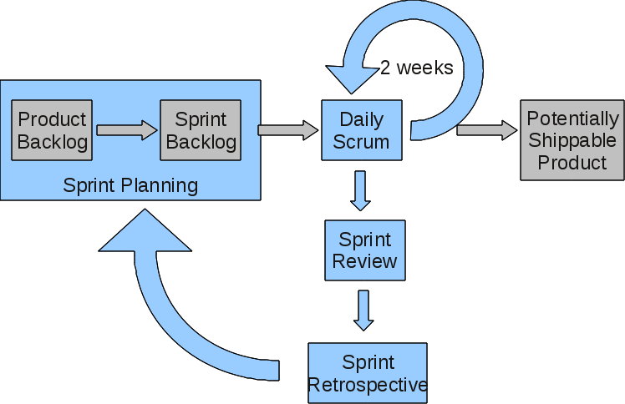

Figure 7: Incremental model

**Chapter 5**

**Implementation**

# Implementation

In this chapter, we’ll focus on the implementation of the web application where users can perform classification activity on this mobile application. The most important goal of this phase is to develop the application. The work in this phase should be much more straightforward because of the work done in the planning and design phases. This phase involves changing design specifications into executable programs.  When the design is there, developers can have an idea of the looks of the application. All that is needed by developers is to put them in one place to understand.

* A robust JavaScript library called React is used in the development of the oral disease diagnostic system. React is well-known for its ability to create dynamic and intuitive online applications. Because of its component-based architecture, React makes it possible to create reusable user interface components, which expedites the development process and guarantees consistency in the application's design. It improves the user experience overall by facilitating fluid rendering and offering effective data flow management.
* The database schema is carefully designed to optimize queries, ensuring quick retrieval of information. Additionally, data normalization techniques are applied to eliminate redundancy and improve data integrity. Indexing is utilized strategically to speed up search operations and enhance overall database performance.

## Algorithm

A general algorithm for is:

### User Authentication:

* The user enters their login credentials to access the app.
* The app verifies the credentials against the database and grants access if they are correct.
* If the credentials are incorrect, the user is prompted to re-enter them.
  + 1. **Sign Up Module:**
* The user enters their credentials on the sign-up page, typically finding fields to input login credentials. These usually include:

1. Username: Enter your unique username.
2. Email: Enter your email address associated with your account.
3. Password: Create a strong and secure password following the app's password requirements (e.g., length, special characters, etc.).
4. Confirm Password: Re-enter the password to confirm accuracy.
   * 1. **AI Module**

* This is the main module of this project developed by using the very efficient algorithm named Vision Transformer (ViT).

## User interface

The application's interface is designed to be straightforward and intuitive, ensuring ease of use for the user. The user will be able to navigate and utilize the application independently without relying on external assistance.

### Login/Signup Page

shows the login page for the doctor or patient. Here a user will provide his/her username and password to log in.

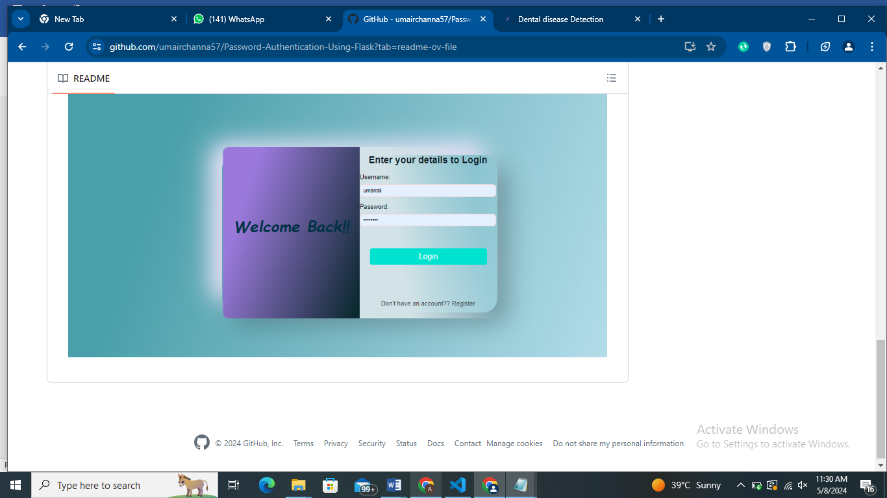

Figure 8: Login/Signup Screen

### Dashboard

After login or signup, dashboard screen shown in below image will appear. From there, user can go to further sub-screens.

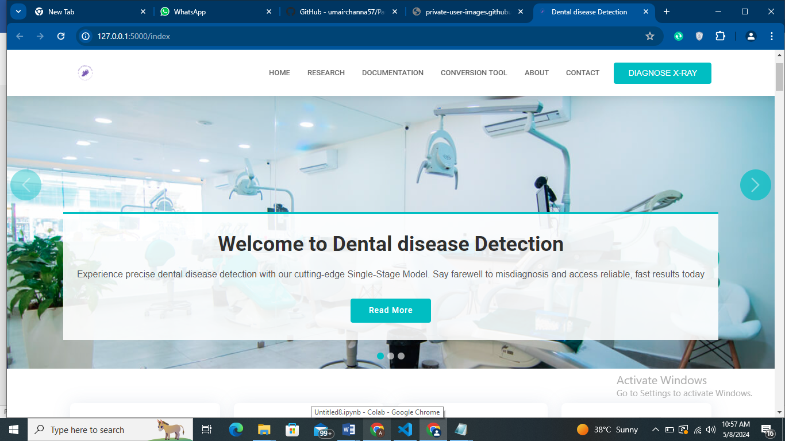

Figure 9: Main Dashboard

### Disease Prediction Module

From main dashboard, user can go to the disease detection module by clicking on Diagnose X-ray button as shown in Figure 10. Here, user can simply select an image and do prediction.

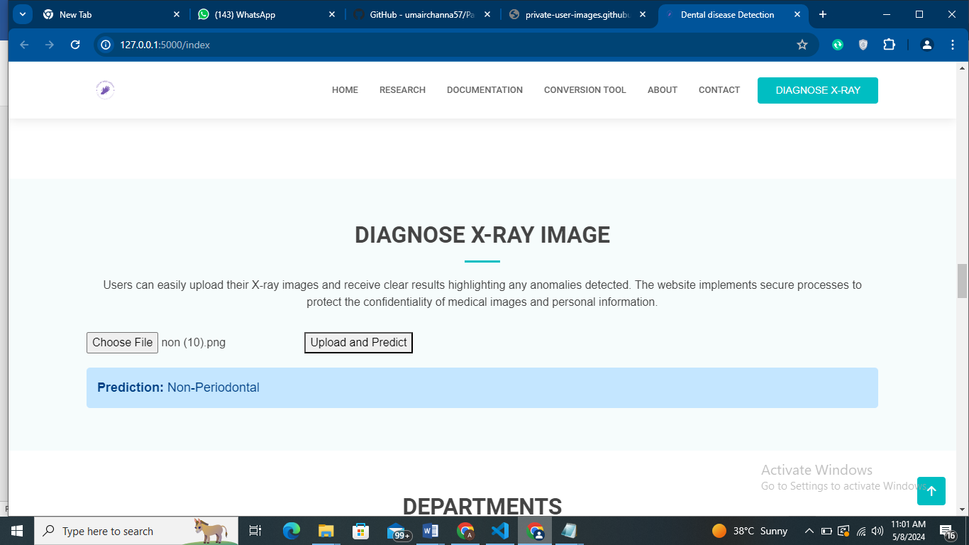

Figure 10: Disease Prediction Module

### Gallery

Figure 11 shows the gallery page of our website where we just added some medical images.

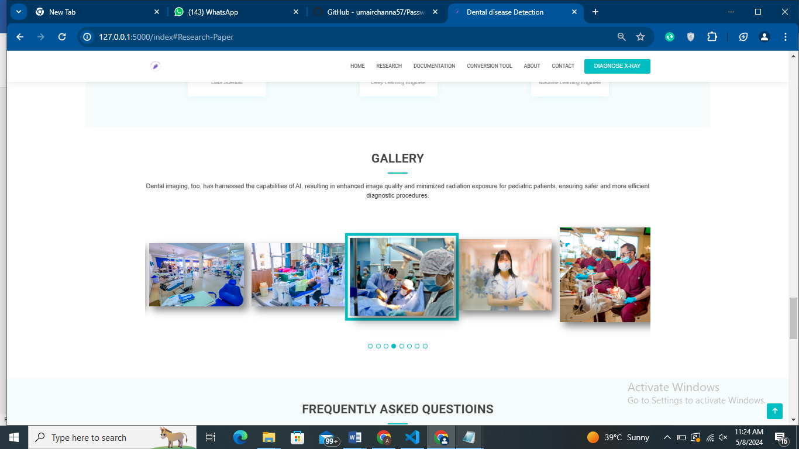

Figure 11: Gallery

### About us page

The page is giving information about the organization with which we are collaborating and also giving details of our University.

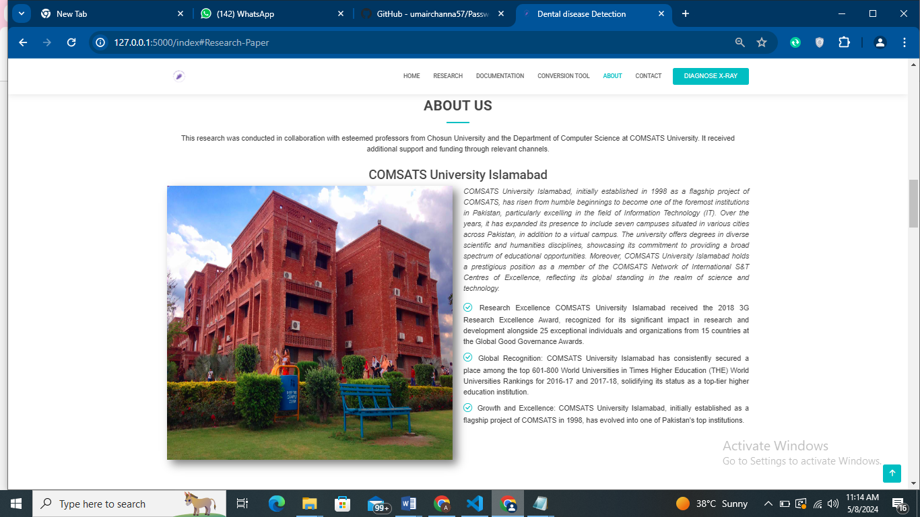

Figure 12: About us page

## Screen objects and actions

In our web-based oral disease diagnostic application, the interface elements and functionalities are meticulously crafted to offer users a seamless and intuitive experience. The primary screen presents easily accessible modules such as image upload. Upon accessing the authentication section, users are prompted with input fields to provide their personal information. Upon successful entry, the application displays the user dashboard. Within the AI module, users have the capability to upload images, which are then processed by the model to classify the specific oral disease depicted in the image. The app's design and layout prioritize user-friendliness, aiming to provide an intuitive experience. This design approach ensures effortless navigation through the application, enabling users to promptly access the necessary information."

**Chapter 6**

**Testing and Evaluation**

# Testing and evaluation

Ensuring the dental disease classification system's accuracy, dependability, and functionality is largely dependent on the testing and evaluation phase. This chapter describes extensive testing procedures that cover multiple stages to ensure project requirements are met and excellent performance is achieved.

## Manual testing

The foundation for verifying user interactions and system features in the oral disease classification application is manual testing. The specific manual test cases are highlighted in the table below:

Table 9: Manual Testing

|  |  |  |  |
| --- | --- | --- | --- |
| **Test Cases** | **Expected Result** | **Actual Result** | **Pass/Fail** |
| App Installation | Successful installation without errors | Successful | Pass |
| User Authentication | Valid user login and access to the system | Successful | Pass |
| Image Upload | Successful upload of skin lesion images | Successful | Pass |
| Image Classification | Accurate classification of uploaded images | Successful | Pass |
| Error Handling | Appropriate error messages on system failure | Accurate | Pass |
| User Interface | Intuitive and user-friendly application design | Accurate | Pass |
| Performance | Smooth navigation and responsive application | Accurate | Pass |

### System testing

System testing is the process of verifying that the application functions as intended in the overall system environment. The following table shows the test cases and results for system testing:

Table 10: System testing

|  |  |  |  |
| --- | --- | --- | --- |
| **Test Cases** | **Expected Result** | **Actual Result** | **Pass/Fail** |
| Compatibility with Devices | Proper functionality across various devices | Compatible | Pass |
| Integration with AI Models | Seamless integration of AI models | Compatible | Pass |
| Data Security | Confidentiality and integrity of user data | Secure | Pass |
| Application Response Time | Acceptable response time for user queries | Reliable | Pass |
| Error Handling | Effective handling of system errors | Effective | Pass |

### Unit testing

Unit testing is primarily concerned with assessing discrete elements and features, such as the AI models used in the classification of dental disease. An overview of particular test cases carried out at this level can be found in the following table:

Table 11: Unit testing

|  |  |  |  |
| --- | --- | --- | --- |
| **Test Cases** | **Expected Output** | **Actual Output** | **Pass/Fail** |
| AI Model Training | Successful training of the AI models | Accurate | Pass |
| Model Prediction on Test Data | Accurate predictions on test datasets | Accurate | Pass |
| Sensitivity Analysis | Analysis of model sensitivity metrics | Accurate | Pass |
| Robustness Testing | Robust handling of diverse lesion images | Effective | Pass |
| Performance Testing | Model performance under varying conditions | Effective | Pass |

## Integration testing

Verifying the smooth integration of dental disease classification system components is the main goal of integration testing. A list of specific test cases carried out during integration is provided in the following table:

Table 12: Integration testing

|  |  |  |  |
| --- | --- | --- | --- |
| **Test Cases** | **Expected Output** | **Actual Output** | **Pass/Fail** |
| Integration of AI Models | Proper integration with the application | Accurate | Pass |
| Image Upload and Processing | Correct handling and classification of images | Accurate | Pass |
| Error Handling | Analysis of model sensitivity metrics | Accurate | Pass |
| Data Transmission | Reliable data exchange between system modules | Effective | Pass |

## Summarized Evaluation

The assessment emphasized the salient features of the oral disease classification application, such as precise disease identification, a user-friendly interface, and strong data security protocols. Nonetheless, shortcomings that were discovered included the necessity for performance optimization, enhanced error handling, and increased resilience when managing various types of oral diseases. The suggestions center on improving performance using optimization and profiling tactics, improving error messaging for user assistance, constantly enriching the model with a variety of datasets, putting in place a feedback system for model enhancement, and strengthening data security measures. These improvements are intended to strengthen the application's effectiveness, user-friendliness, and precision in identifying different kinds of oral disease, ultimately supporting dentists in making accurate and timely diagnoses.

**Chapter 7**

**Conclusion and Future Work**

# Conclusion and future work

## Conclusion

To conclude, the creation of an integrated system utilizing deep learning models and datasets for oral disease diagnosis signifies a significant breakthrough in dentistry. This system stands as an asset for dental practitioners, offering substantial support in the early identification of various oral diseases. Ultimately, its implementation holds the promise of enhancing patient outcomes by facilitating timely interventions and broadening access to essential oral healthcare services.

## Future work

1. **Enhanced Model Robustness:**

Explore advanced data augmentation methods and additional preprocessing steps to improve the model's robustness.

1. **Transfer Learning and Fine-Tuning:**

Investigate the potential of transfer learning and fine-tuning strategies with larger and more varied datasets to enhance the model's adaptability to different medical imaging domains.

1. **Integration of Clinical Data:**

Collaborate with healthcare professionals to integrate clinical data, including patient history and diagnostic information, into the system for improved accuracy and clinical relevance.

1. **Explanability and Interpretability:**

Implement features for model explainability and interpretability, enabling healthcare practitioners to understand and trust the model's predictions.

1. **Continuous Dataset Expansion:**

Prioritize continuous expansion of the dataset with new, diverse tooth images to keep the model up to date with evolving characteristics.

# References

1. Lee, J.-H., Kim, D.-H., Jeong, S.-N., & Choi, S.-H. (2018). Detection and diagnosis of dental caries using a deep learning-based convolutional neural network algorithm. *Journal of Dentistry*, 106-111.
2. Patil, S., Kulkarni, V., & Bhise, A. (2019). Algorithmic analysis for dental caries detection using an adaptive neural network architecture. *Heliyon*.
3. Zhu, Y., Xu, T., Peng, L., Cao, Y., Zhao, X., Li, S., . . . Liang, S. (2022). Faster-RCNN based intelligent detection and localization of dental caries. *Displays*.
4. AL-Ghamdi, A. S. A.-M., Ragab, M., AlGhamdi, S. A., Asseri, A. H., Mansour, R. F., & Koundal, D. (2022). Detection of dental diseases through X-ray images using neural search architecture network. *Computational Intelligence and Neuroscience*, *2022*, 1–7. https://doi.org/10.1155/2022/3500552
5. Fatima, A., Shafi, I., Afzal, H., Mahmood, K., Díez, I. de la T., Lipari, V., Ballester, J. B., & Ashraf, I. (2023). Deep learning-based multiclass instance segmentation for dental lesion detection. *Healthcare (Basel, Switzerland)*, *11*(3), 347. https://doi.org/10.3390/healthcare11030347
6. Mine, Y., Iwamoto, Y., Okazaki, S., Nakamura, K., Takeda, S., Peng, T.-Y., Mitsuhata, C., Kakimoto, N., Kozai, K., & Murayama, T. (2021). Detecting the presence of supernumerary teeth during the early mixed dentition stage using deep learning algorithms: A pilot study. *International Journal of Paediatric Dentistry*, *32*(5), 678–685. https://doi.org/10.1111/ipd.12946
7. Okazaki, S., Mine, Y., Iwamoto, Y., Urabe, S., Mitsuhata, C., Nomura, R., Kakimoto, N., & Murayama, T. (2022). Analysis of the feasibility of using deep learning for multiclass classification of dental anomalies on panoramic radiographs. *Dental Materials Journal*, *41*(6), 889–895. https://doi.org/10.4012/dmj.2022-098
8. Oztekin, F., Katar, O., Sadak, F., Yildirim, M., Cakar, H., Aydogan, M., Ozpolat, Z., Talo Yildirim, T., Yildirim, O., Faust, O., & Acharya, U. R. (2023). An explainable deep learning model to prediction dental caries using panoramic radiograph images. *Diagnostics (Basel, Switzerland)*, *13*(2), 226. https://doi.org/10.3390/diagnostics13020226
9. Sheng, C., Wang, L., Huang, Z., Wang, T., Guo, Y., Hou, W., Xu, L., Wang, J., & Yan, X. (2022). Transformer-based deep learning network for tooth segmentation on panoramic radiographs. *Journal of Systems Science and Complexity*, *36*(1), 257–272. https://doi.org/10.1007/s11424-022-2057-9